FAZAIA BILQUIS COLLEGE OF EDUCATION FOR
WOMEN PAF NUR KHAN, RWP

Parallel Distributed Computing (LAB)
Lab 3 Tasks
Submitted to
Ma’am Iffat

Submitted by
Javeria Fazal
BSCS 7th B
F21-62

Task 3
- Find out ip address of your machine via ipconfig.
- Using multithreading send a message from one computer system to any other computer system in the lab.
- First, go to Command Prompt and note down the ipv4 address of the system via ipconfig command.
- Decide which systems you want as Client and server.
(Client system will write down code of only client portion and Server system will write of only server portion. Server will execute code first as well.)
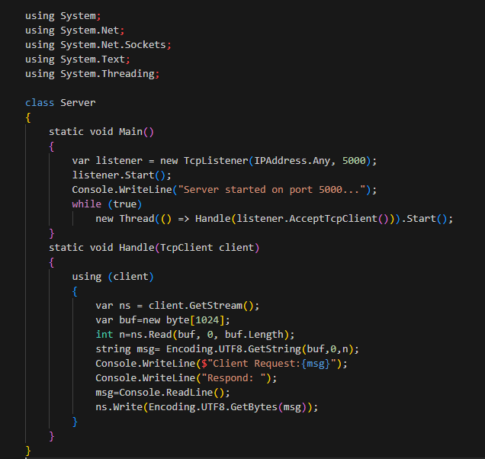
- Source Code (Server side):
Figure 1
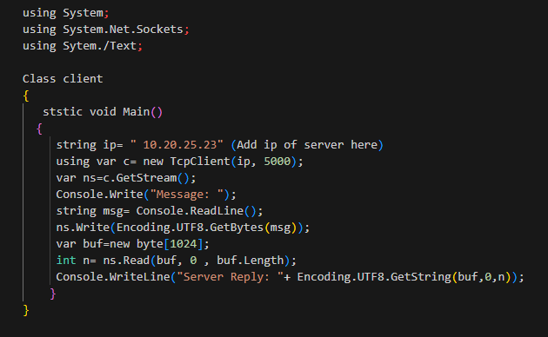
- Source Code (Client side):
Figure 2
- Output:
- Conversation between client and server:
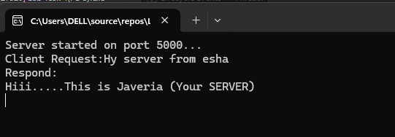

Task 4
- Find out ip address of your machine via ipconfig.
- Using multithreading send a message from one computer system to any other computer system in the lab.
- Use loop this time of 10 messages request and reply.
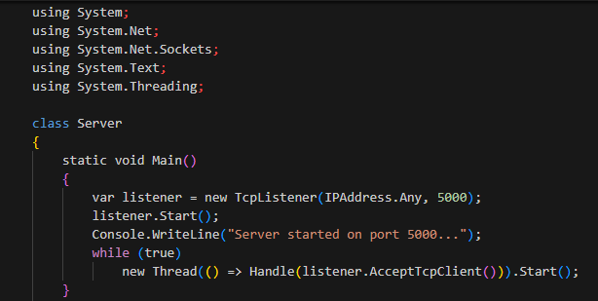
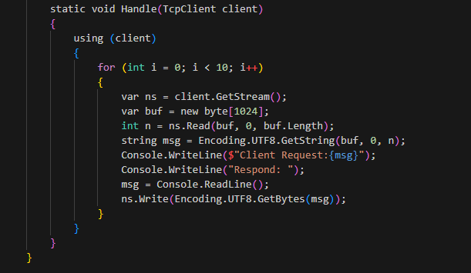
- Source code (Server Side):
Figure 3

- Source code (Client Side):
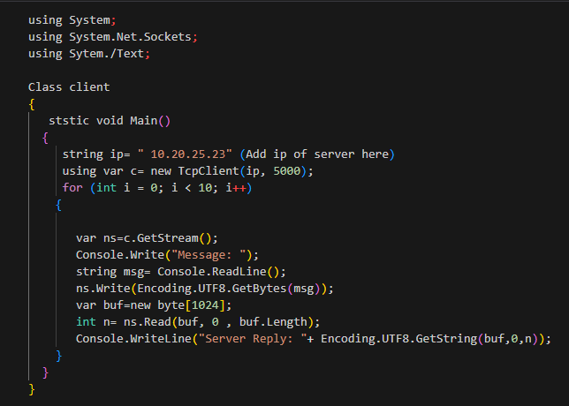
Figure 4
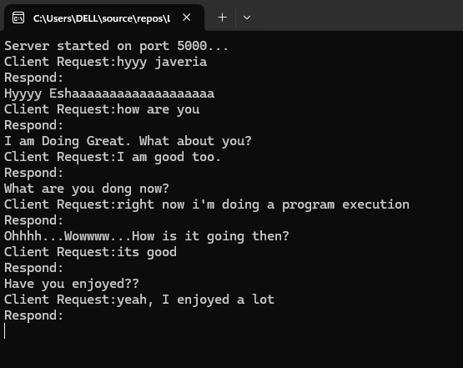
- Output (Coversation between client and server):
Figure 5

